INTRODUCTION

Outer space is the next largely unexplored realm for our species, creating a wealth of possibilities for music composition through its imagery, sounds and concepts. This thesis discusses my portfolio of compositions inspired by space in the context of pre-existing space-themed works. The pieces range from solo to mixed ensemble and embody various astronomical phenomena such as craters, full moons, skies, planets and the imagined experience of being trapped in a black hole. Some works use electromagnetic waves of various astronomical phenomena as a sonic foundation including pitch material present, made audible by use of spectrograph. My compositional research process is largely intuitive and involves immersing myself in recorded and theoretical source material and experiencing the massive volume of NASA photographs, videos and audio recordings. I imagine I am there, or travelling around the subjects, abstracting the patterns and sensations into an outline of the melodic shape on the page.

- BACKGROUND AND INFLUENCES

History of Music and Astronomy
In the 6th century BC, Pythagoras identified that the pitch of a musical note is in proportion to the length of the string that produces it. He then expanded the idea to include the sun, moon and planets, proposing they all emit their own unique pitch in his theory known as ‘Music of the Spheres’. In 380 BC Plato mused that astronomy and music are “twinned.” In Plato’s Republic he wrote "As the eyes, said I, seem formed for studying astronomy, so do the ears seem formed for harmonious motions: and these seem to be twin sciences to one another, as also the Pythagoreans say". In 1619 Kepler wrote Harmonics Mundi, or the Harmony of the World, a treatise on his theory of elliptical planetary orbits and linked musical rations to the orbital dimensions and proposed that each planet has a link with a particular musical interval. Since then astronomical objects such as the moon, sun and stars have been a popular topic for music compositions through the ages in all genres. For example, Beethoven’s Moonlight Sonata, Holst’s Planet Suite, Pink Floyd’s Dark Side of the Moon, up to Björk’s recent Cosmogony in 2015, a hymn like song about the birth of the universe.

Many historical theories on the mathematical and philosophical connections between music and astronomy are inductive, based on the inference of general laws from a particular instance. While notable from a musicological historical perspective, they hold no strong influence on my interpretation of space and music. I have taken an experiential stance, seeking stimulus from the recordings and interpretations of space phenomena that are becoming more and more detailed as technology improves.

The influence of astronomy can also be seen in the works of contemporary Australian composers such as Michael Smetanin’s Mysterium Cosmographicum (2005) for piano and orchestra based on Kepler’s theories of planetary orbit patterns, Rosalind Page’s Courbe Dominante for flutes and Saturnian sound spectra (2006), Ross Edwards’ Full Moon Dances (2011) for saxophone and orchestra and Damien Ricketson’s Ptolemy's Onion (1998) for bass flute and string quartet, to name a few.

“Space Sounds” – Recording and Interpretation
Space “sound” is, on the whole, a construct. Sound, as humans experience it, does not travel through space because there is no matter in the vacuum of space to vibrate. Recordings from space that are transformed into sound tend to be mathematical constructions based on visual or electromagnetic data. Even if the captured visual or radio frequencies are likely to be creating sounds at their point of origin, much of the time these frequencies are not within the human range of perception. “Space sound” in this thesis will, therefore, refer to real, recorded phenomena that have been transcribed and the data used as a basis to generate sound within human perception.
The first known “noises from space” occurred during the 1969 Apollo 10 lunar landing when eerie sounds were heard over the radio as the spacecraft passed over the dark side of the moon, the recording of which was released to the public by NASA in February 2016. Since then various sounds have emerged from space, especially more in the last few decades as space probes have better equipment onboard to measure electromagnetic waves and record radio emissions. Increasingly over the last fifteen years a wealth of sounds has become available, whether from NASA’s Cassini mission in orbit around Saturn finding and recording radio emissions that seem to come from Saturn’s rings (https://www.nasa.gov/mission_pages/cassini/main/), or NASA’s solar dynamics observatory’s sun sounds (http://sdo.gsfc.nasa.gov/).

To my ears, the space sounds are eerie, otherworldly and seem to have origins in nature. There are definite and evolving pitches, often close to the harmonic series (i.e. fifths, fourths, octaves etc.). The manner in which the pitches change and different tone colours emerge remind me of whale sounds and a deep sense of being primal and instinctual and radically detached from society.

Dr Paul Francis’ Space Sound Collection
I came across the space sounds of astronomer Dr Francis, an astronomer and lecturer at the Australian National University, during a google search and discovered his online library of mp3 files: http://www.mso.anu.edu.au/pfrancis/Music/. They are the electromagnetic waves of various astronomical phenomena (eg solar flare, nebulae, passing comet) converted to audible sound with use of a spectrograph. Most of the original source waves are from NASA data. On his website he explains his method of obtaining these sounds, which consists of 9 stages (more detail on his website: http://www.mso.anu.edu.au/~pfrancis/Music/):
“1. Input spectrum. You will need an observed or synthetic digital spectrum covering a wide range of wavelengths.
2. Convert to frequency.
3. Reduce the frequency. The frequency will thus need to be reduced by a factor of around 1.75 trillion.
4. Choose the phases. A phase must be assigned to each frequency bin.
5. Do the Fourier Transform. This spectrum is then converted into a discretely sampled waveform by taking its Fourier Transform.
6. Output the discretely sampled waveform as an ASCII file. The first line should list the sampling rate, while subsequent lines consist of an increasing integer and the sampled flux value (in the range –1 to 1).
7. Convert the ASCII file into a “.wav” file. To make this conversion I use the freeware SoX Sound exchange utility (http://sox.sourceforge.net/).
8. Combine sounds. It may be helpful to combine different sounds, change the volume, record voice-overs etc. I use the Apple Garage-band program.
9. Convert to a compressed format. The “.wav” files are large (1 MB for an 11 sec clip). Converting them to a compressed format dramatically reduces the size with little penalty in quality. “

While over 70% of observations with most research telescopes consist of some form of spectroscopy, which is essential to researching astronomical phenomena, space pictures dominate the general public’s perception of astronomy. In 2014 NASA released a Soundcloud library of space-related sounds (https://soundcloud.com/nasa). Other astronomers, including Prof Donald Gurnett from University of Iowa as well as Dr Francis, have also presented a wide variety of sounds, including the big bang, solar and stellar oscillations and the winds on Titan. In these cases, the signals being converted to sound are acoustic pressure oscillations. When I enquired as to whether I could use Francis’ sounds for my compositions, he was delighted, as the reason he made them public was in the hope of them being used and shared creatively.

Music Composition and Space Sounds
The earliest notated acoustic composition I can find that officially uses space sounds is Terry Riley’s Sun Rings (2002) for string quartet, choir and pre-recorded sound. With ten movements and lasting one hour thirty minutes, it was premiered by Kronos Quartet at University of Iowa and involves celestial projections. The sounds of space came from plasma wave receivers built by Prof Gurnett and flown on a variety of Earth orbiting and planetary spacecraft over a period of 40 years. Also incorporated in the soundtrack were spoken words from astronomers and astronauts. The effect is electrifying and all-encompassing, and somewhat theatrical, with the spoken word element. The movements are: 1 - Sun Rings Overture, 2 - Hero Danger, 3 - Beebopterismo, 4 - Planet Elf Sindoori, 5 - Earth Whistlers, 6 - Earth/Jupiter Kiss, 7 - The Electron Cyclotron Frequency Parlour, 8 - Prayer Central, 9 - Venus Upstream and finally 10 - One Earth, One People, One Love.

Though I did not attend a live performance, I have examined a film of excerpts of the premiere on Kronos Quartet’s website, uploaded in 2012. I was impressed by the effectiveness of the interplay between recorded space sounds and acoustic instruments. Each movement displays different and diverse musical and pre-recorded sound palettes. The opening movement, Sun Rings Overture, is a collection of NASA operatives’ spoken radio communications accompanying sustained held string pitches, whereas Movement 2, Hero Danger, is more acoustically rhythmic and modal using space sounds based on spectrograph data. Movement 7, The Electron Cyclotron Frequency Parlour, uses sounds from plasma wave receivers on the Twin Voyager spacecraft collected over twelve years and has very sparse sustained pitches from the quartet. Movement 8, Prayer Central, adds choir and uses it as an instrument with frequent use of the syllable “Ahh” rather than actual words. The texture of the choir ensemble blends extremely well with spaces sounds. As is clear from the title of the movements, Riley has a spiritual approach without being specifically religious. I felt an affinity with his style of musical synthesis, his personal spirituality and his astronomical inspirations. He writes in programme notes of the original concert (2002): “Space is surely the realm of dreams and imagination and a fertile feeding ground for poets and musicians. Do the stars welcome us into their realm? ..Do they wish us to come in peace? I am sure of it.”

There are a small number of active ensembles in Australia that have a strong astronomical theme. The Sydney based Syzgy ensemble lead by Colin Bright has performed some space themed shows with projections of live star data to notated contemporary classical pieces and improvisational passages. Melbourne based Andrea Keller and her quartet performed a series of concerts around Australia called “From Ether” (2013, http://www.andreakellerpiano.com.au/from-ether/). This is designed as a live and visceral soundscape that accompanies a film of photographic images, tweeted down to Earth by Canadian astronaut Chris Hadfield working on the International Space Station. USA based Fabrica Music Area, made a four-song EP, titled 80UA, named after the dimensions of the solar system as measured in astronomical units and crafted solely using NASA’s original recordings from their SoundCloud library of space sounds.

In 2015 I have formed my own ensemble Ephemera (http://ephemeraensemble.com) to musically explore celestial landscapes such as pulsars, craters, planetary atmospheres, stars, sun and void, using the space sounds. Merging the sound worlds of jazz, classical and flamenco musicians and using original NASA space footage, the performances create an original sonic and visual experience.

NASA Space Imagery Resources
There are many sources of astronomical data, recordings and images, especially from terrestrial origins, and from space agencies such as European Space Agency or the Russian Federal Space Agency, however the National Aeronautics and Space Administration (NASA) is dominant in recordings made from space and its recent output has been compelling and of higher quality. Much of the footage, pictures and sounds are open source on NASA website and members of the public have permission to use and share providing there is acknowledgement.

- MY BACKGROUND AND COMPOSITIONAL PROCESS

My Background
I am a published composer, pianist, flautist and teacher based in Sydney. With international classical training at Bristol University and Bath Spa University (UK), Hildesheim University (Germany) and continuing postgraduate composition at Sydney Conservatorium, I have branched into jazz, experimental live theatre, flamenco fusion and free improvisation. My compositions weave a tapestry of unique tonal patterns and rhythms creating an original and intuitive musical voice that is a hybrid of my sonic experiences, with a particular focus on astronomical ideas. Since 2011, eight of my compositions have been published by the Australian music publishing house, Wirripang.
My flamenco performing experiences have influenced my compositional style by inspiring me to use of flamenco tonalities and introducing me to other performance elements, in this case dance, creating a more total experience. My flamenco journey started while studying in Germany in 2001 when I joined a tango/flamenco ensemble Faux Pas that performed around Germany and Italy. Since then I have joined similar ensembles in UK and Australia. A highlight was opening the Adelaide Fringe Festival with Flamenco Australia and performing regularly in 2012 and 2013 with eight-piece group Pena Flamenca, at festivals such as Darling Harbour Fiesta and shows at the Basement, Venue 505 and many others. Flamenco tonality often revolves around the Phrygian mode (with flattened and sharpened 3rd) as well as other modes such as Lydian and Aeolian. These modes are prominent in my compositions. The performance aspect showed me that it is thrilling when another element is added to the music - transforming it into another realm. My music theatre chamber piece Dark Genesis was particularly influenced by this transformative aspect.

My live theatre experiences have also influenced my compositional style by demonstrating how exciting having a full narrative with live music can be, how effective a small well-rehearsed ensemble can be and how abstract the narrative can be and still work live. In 2013 I was commissioned by Marquez Laundry Theatre Company to write music for Fred and Ginger at Sydney Fringe Festival. I was a character on stage, wrote the music and performed it every night for eight days at Old 505 Theatre. Alicia Gonzalez and I co-devised the piece for the two-piece ensemble. This was intense and moving as I had never acted before, but it showed me how pure music can be taken into another realm if there is a narrative skillfully executed, while also making it more accessible. There were only two of us on stage for forty-five minutes but no one talked or even hardly coughed because the show was fully engaging and exhilarating. The narrative was rather abstract, drawing from the Beckett tradition, but there was resolution of a kind by the end. The co-devising process taught me how fluid theatrical writing can be and how abstract “plots” can be and still work on stage. Dark Genesis is influenced by this experience in that it has a small ensemble (five instruments and two characters) and has an abstract plot.

My jazz and improvisational performances have led me to believe in the symbiotic relationship between performer and composer. In order for a musician to engage with the composition on a deep level and perform it well, they need to feel they own and can put their personal stamp on it in some way. They can put a very clear stamp on it if they are allowed to improvise. Improvisation adds immediacy, intimacy, and the sense that each playing is unique. It is also more rewarding and fulfilling as a performer. In most ensembles I have played in I frequently improvise e.g. jazz quartets, flamenco/tango fusion ensembles, free jazz duos and others. I often include improvised sections in my compositions, and if I am performing them live I will often improvise sections. Craters of Rhea has an extended improvised section. I wanted to also include one in Dark Genesis but decided that with a seven-piece ensemble it wasn’t practical. My connection with improvisation is also linked to my compositional process, which is quite intuitive and often begins with improvising fragments of a melody. My jazz experience is apparent in nearly all my compositions through use of extended jazz chords i.e. ninths, elevenths and thirteenths, as a harmonic basis.

I spent my early childhood in rural Somerset, UK, born to an Australian mother and English father. The pastoral setting of south west England created an imprint of the importance of landscape, while the vivid Australian land provide a striking contrast in texture and mood. While astronomy has always fascinated me, having bought a telescope when I was thirteen with all my saved money, it is the celestial landscapes in particular that draw me in. This impression of spatial vastness reflected musically is apparent throughout my portfolio, with many specific references to astronomical terrain. Australian composers who are deeply affected by the expansive Australian landscape and who have inspired me are Peter Sculthorpe, Anne Boyd and Ross Edwards.

My solid classical training has also nurtured a love of Debussy. Significant features of my music that can be linked to Debussy are: use of parallel chords using fifths and fourths, lyrical melodies that evade a steady beat, exploring the subtle nuances of instrumental timbre, and shifting time signatures.
My Compositional Process
My compositional process is based on improvisation and connected to my personal spirituality and meditation on extra-musical ideas. I have used a number of approaches; viewing space imagery and imagining I am present in the picture, exploring pitch material from space sounds and exploring astronomical concepts within musical textures.

Pieces in the portfolio based on viewing space imagery are Craters of Rhea for double bass and loop pedal, Full Moon for solo trumpet, Aurorae Sinus for flute, trumpet and double bass, Mars for double bass and piano and Sky Pieces for solo piano. I imagine the mood and vision of the place and at times mimic the landscape contour in the melodic lines.

Other works are based on exploring the pitch material from space sounds by looping the sounds meditating on the pitches and their origin. Works that arose from this approach include Floating in Space for solo flute and sections of Dark Genesis for mixed ensemble. I listen to the sources frequently and test what I have written against the sounds. The aim is not to harmonise, but to use the sounds as a stage for the piece to play across.

Always at some point in the process I go to the piano and, through improvisation, find a series of melodic shapes, fragments, chords that fit together. I then notate the score in Sibelius and start structuring the piece with practical considerations for instruments in mind. Following this I make multiple drafts and workshop the ideas with musicians to develop a coherent and effective composition.

- ANALYSIS OF WORKS

- FLOATING IN SPACE for solo flute and nebulae
I wrote this piece after discovering the space sounds compiled and produced by Dr Paul Francis, discussed above. The Nebulae track was particularly evocative and inspired me to write a piece for myself to play, accompanied by these sounds, as a meditation on the nature of void in space using the best instrument to invoke a calm state of mind through breathing – the flute. In this sense I have been influenced by the basic tenets of Zen Buddhism, specifically the blowing technique of the Japanese end-blown bamboo flute shakuhachi, as a means to meditate on nothingness, or void, which is closely linked to my personal spirituality. Musicologist Jay Keister states: “The Fuke sect of Buddhists practiced a form of shakuhachi meditation known as suizen, or blowing Zen”. Suizen is the concept of self-realisation through meditation on nothingness during improvisation. Features shakuhachi Zen improvisation include lack of steady pulse, fragmented melodies, pitch bends, wide use of sustained notes as the controlled and deep breathing is paramount in meditation, and use of a pitch collection roughly similar to the Western minor pentatonic scale, and also as that was the tone pattern built into the flute. Similarly Floating in Space has all these features with the addition of the backdrop of space sounds.

When listening to, for example, Nebulae, two main pitches can clearly be heard: Middle C, C above Middle C and F above Middle C, which is has some of the main pitches from the harmonic series starting on F as the fundamental. I have used these two pitches as tonal centres of the piece. I decided to open the piece with fifteen seconds of the nebulae sounds because they themselves are quite lyrical and calm: there is a flow of overlapping fragments of melody, which sets up the atmosphere for the piece effectively. Following this, a held low F subtly emerges with twelve slow beats of crotchet = 40 bpm with a pause and pitch bend downwards, followed by two grace notes crushed up to a held middle D, setting the tone for a theme of stillness and tranquility with occasional flurries of movement as shown in Example 1.
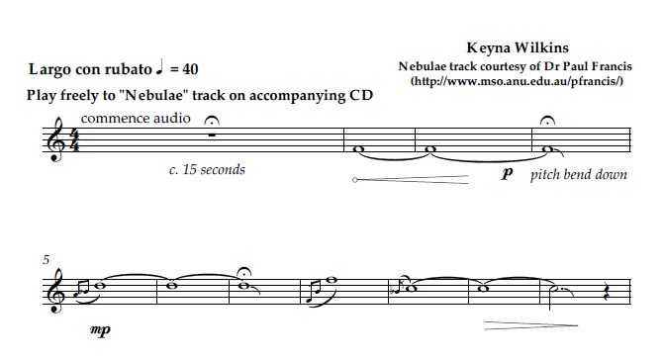
Example 1: Floating in Space, Bars 1-11

The melody develops with fragments appearing and reappearing in various guises. For example, the accelerando semiquaver flutter tongue motif, shown in Example 1.1, returns in A♭ then back to D♭ later in the piece.
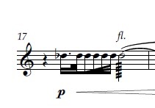
Example 1.1: Floating in Space, Bar 17
The fragments gradually build in intensity through dynamics and faster rhythmic activity until the climax of the piece, which occurs around the middle, bar 27, as shown in Example 1.2, and builds a melodic narrative around F – D♭ – C. The tension around the minor sixth interval is particularly evocative and poignant, being an imperfect consonance. Sound therapist Simon Heather, quoting composer and sound healer Kay Gardner, writes “The minor 6th creates a feeling of poignancy” Indeed, many composers have used this interval to great melancholic effect such as the opening interval in Chopin’s Valse Op 64 No 2 or in Francis Lai’s Love Story main theme.
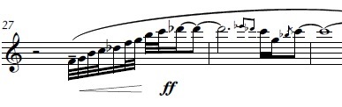
Example 1.2: Floating in Space, Bars 27-28
Structurally the piece is based on melodic fragments that recur and develop throughout in an improvisatory style. A large portion of the pitches are from F minor pentatonic scale (F, A♭, B♭, C and E♭) with the addition of D♭ and B.

- CRATERS OF RHEA for solo double bass and loop pedal
Craters of Rhea was written with regular consultations with Elsen Price, a virtuosic double bass player who specialises in new music and extended techniques. We worked together as a duo and often performed entirely improvised sets together. This experience informed the composition as I knew we both believed in an integrated approach to the composer-performer relationship. Also I knew that there would be very few technical limitations, that he had a loop pedal and was keen to use it. For these reasons the piece is highly diverse musically, uses loop pedal and has a structured improvisation section.

Rhea is the second largest moon of Saturn and has been highly cratered by passing asteroids. It has an icy rocky surface made up of 25% rock and 75% water ice. From afar it looks perfectly spherical, though measurements from NASA’s Cassini mission show that its shape is triaxial, so slightly oval-shaped due to variations in liquid and gravity levels at its core. I have tried to reflect these aspects musically. The opening passage, shown in Example 2, features quintuplets and leaps of a perfect fifth, diminished sixth and augmented octave. The dissonant leaps, falling quintuplet shapes and irregular rhythms mirror the shape of Rhea’s craggy terrain shown in Image 1. Section A (bar 1-32) develops by using same rhythmic material sequentially from different pitches, adding double stops and an accelerando half way through.
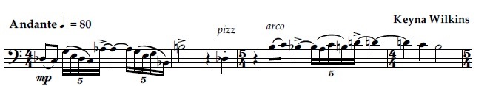
Example 2: Craters of Rhea, Bars 1-4

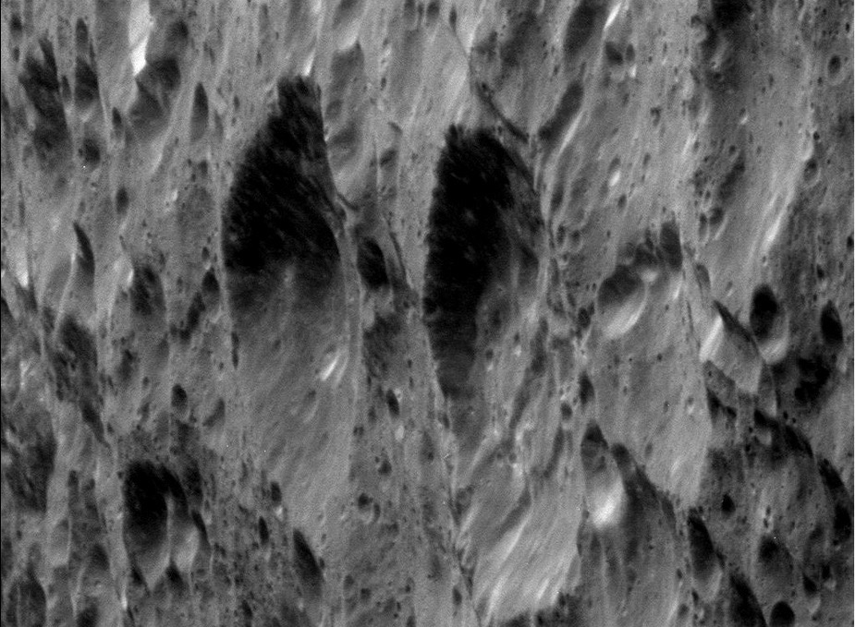
Image 1: craters on Rhea from NASA’s Cassini Mission (2014)

Structurally it has a loose A-B-C-B-D-Improvisation-A-Coda form, as the opening theme A and theme B return in various guises. Section B (bar 33-41) uses glissandi in double stops of thirds, fifths and sixths shown in Example 2.1, symbolising the variations in liquid and gravity at its core, which I have musically interpreted as fluctuating sliding pitches.
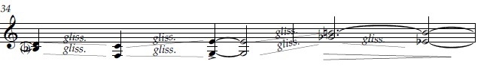
Example 2.1: Craters of Rhea, Bars 34-35
Section C (bars 41-62) is a soulful and intense melody representing the yearning for knowledge about this icy mystery inspired by this picture from NASA’s Cassini Mission, shown in Image 1.1. It marks a distinctive change in character and provides a section where the performer can really indulge in vibrato and lyrical playing, connecting with the mythological aspect of the name Rhea, who in Greek legend was the daughter of the earth goddess Gaia and the sky god Uranus.

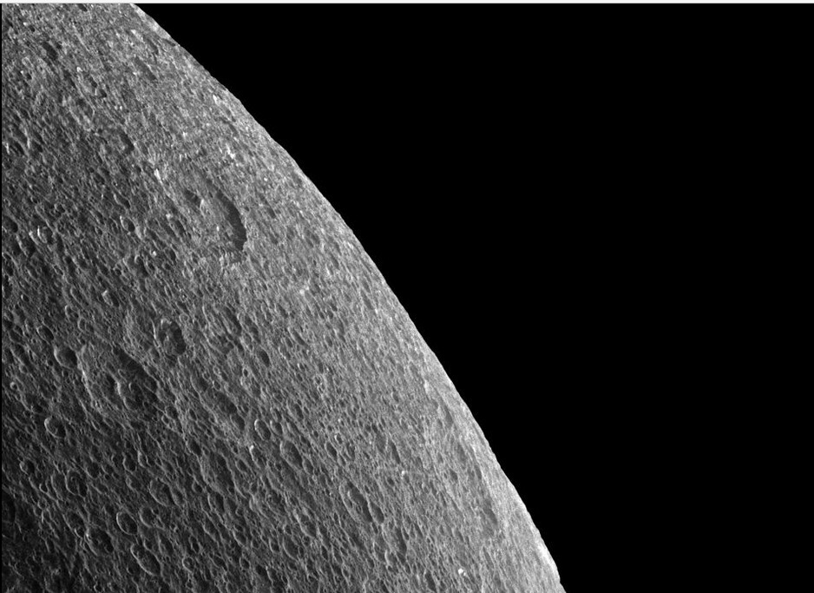
Image 1.1: Rhea’s horizon from NASA’s Cassini Mission (2014)

Following this Section B partially returns (bar 63-72) with a playful staccato ending. Section D (bar 73-102) marks again a striking change in style as the loop pedal is utilized with 2 different voices in parallel perfect 5ths in C Major. The open and disarming nature of the parallel fifths is what attracted me to writing them consecutively as I wanted the tension created to dissolve in some way. The performer is invited to improvise within set pitch parameters which is essentially F Lydian mode with a flattened third as shown in Example 2.2. Over these chords Section A returns in part (bar 103-118) this time a pizzicato version.
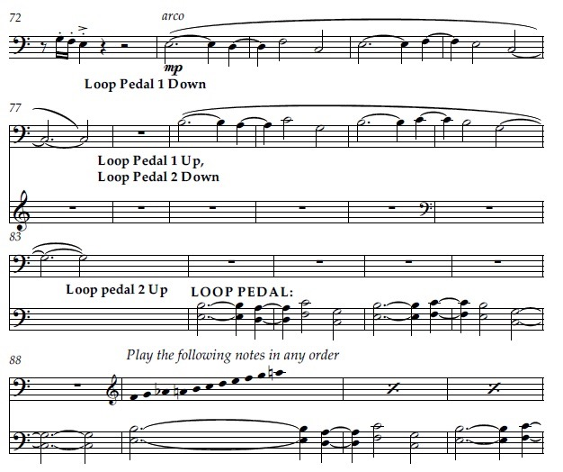
Example 2.2: Craters of Rhea, Bars 71-94

The Coda (bar 199- end) represents the resolution of anguish and struggle in the rest of the piece. It is a melody in C Major over the same parallel fifths on loop pedal as the previous section. The sound of the open fifths, for me, epitomizes nature and sunrise, and was inspired by this picture of Rhea with the light of Jupiter reflecting, as seen in Image 1.2, which puts all the anguish of the first sections into perspective and allows us to see the big picture.
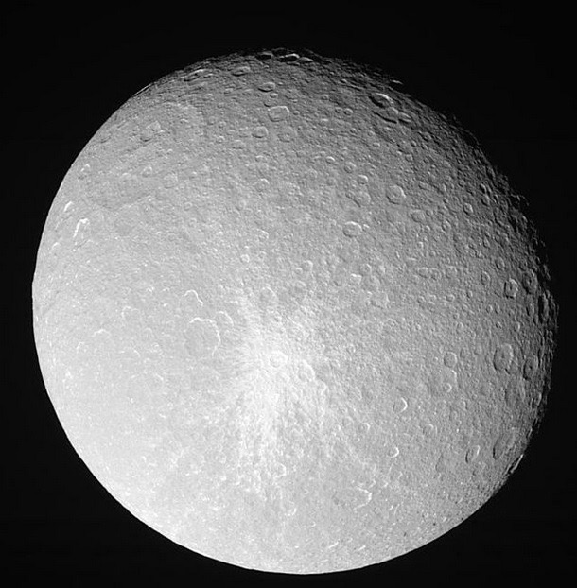
Image 1.2: Rhea from NASA’s Cassini Mission (2014)

- AURORAE SINUS for flute, double bass and trumpet
Aurorae Sinus is a massive crater which appears as a dark feature in the southern hemisphere of Mars and forms part of a feature visible from Earth with telescopes known as the "eye of Mars". I wrote this piece imagining I was standing alone in the middle of it, trying to capture the tranquil and yet alien landscape of the enormous crater that is Aurorae Sinus, as shown in Example 3.

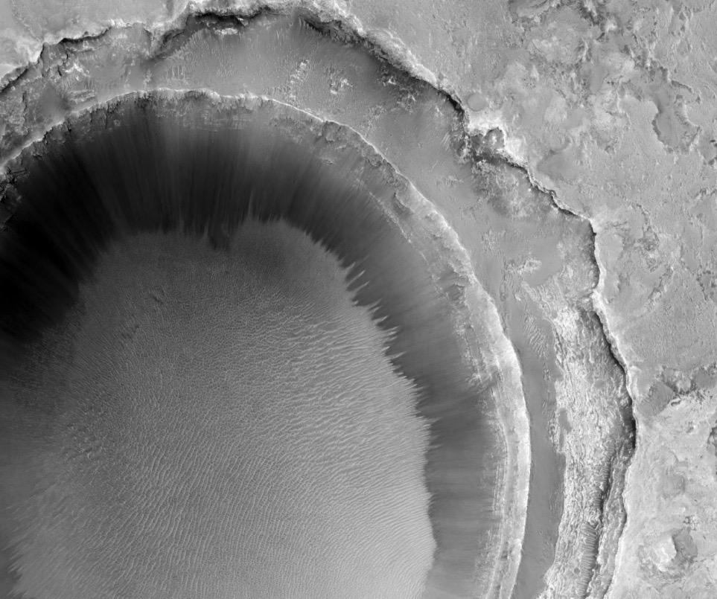
Image 2: Aurorae Sinus from NASA’s Mars Rover Mission

This piece was originally conceived for string quartet but due to the instrumentation of a new ensemble I was working with, I re-devised it for flute, trumpet and double bass, discovered with a few minor changes it worked very well. The composition opens with staggered entries of all three instruments playing sustained notes and fragments often in semitone intervals, creating a sparse and enigmatic atmosphere, as shown in Example 3 focusing on the fundamental sounds of each instrument. These fragments are developed further concluding in with a crescendo three semitone cluster in bar 16.
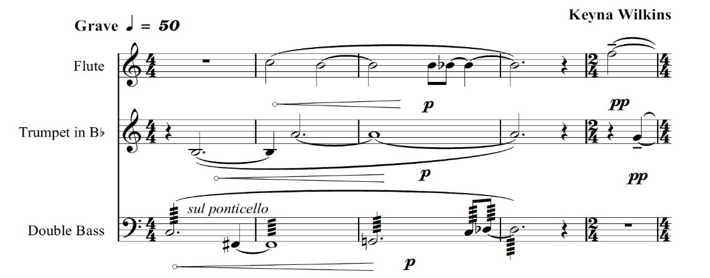
Example 3: Aurorae Sinus, Bars 1-4

Then, as if turning around a corner of the red dust bowl and seeing the sky, the piece transforms into a haunting and somewhat lonely flute melody, roughly in C Phrygian mode with a sharpened third, bringing the human element into play. A triplet trumpet fragment enters as if in response at the end of the flute phrase, as can be seen in Example 3.1.
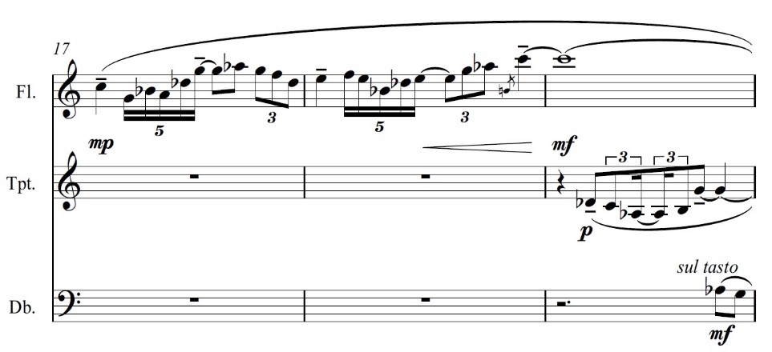
Example 3.1: Aurorae Sinus, Bars 17-19

Both of these motifs are developed using different pitch centres and different instruments for the rest of the piece. For example, the same melody outline occurs in the double bass part from bar 26, this time starting on F and ending in a double stop, with the first interval being a perfect fifth instead of perfect fourth, shown in Example 3.2. The difference between the perfect fifth and perfect fourth is significant as the space between the notes is reduced and suggests restriction and limitation, a turning away, a reclusive gesture.
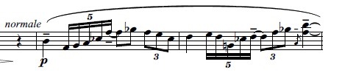
Example 3.2: Aurorae Sinus, Bars 26-28, double bass part

The essence of this piece is about an inner dialogue confronting the possibility of being alone in the universe. It ends with a question mark.

- MARS for double bass and piano
Mars was originally written and published for tuba and piano, but as I was working frequently with double bassist Elsen Price, I decided to re-imagine it for double bass and piano after the success of Craters of Rhea. With a few minor alterations, it worked well because the earthy and rich tone colour of the double bass seems to reflect the Martian landscape quite effectively. I was envisaging NASA’s Curiosity Mars Rover, as seen in Picture 3, driving over Martian boulders along the red plains.

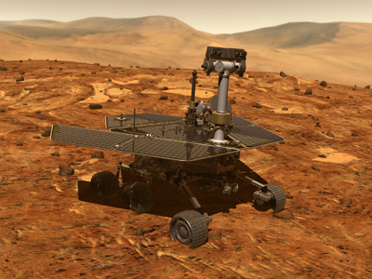
Image 3: Mars Curiosity Rover 2015 (NASA’s Mars Exploration website)

Part 1 is called Red Dirt and is in ABA form with the opening theme using bold, almost heroic ascending semiquavers. The piano part represents the red lumpy soil and the double bass part symbolises a bumpy and energetic ride along it as can be seen in Example 4.
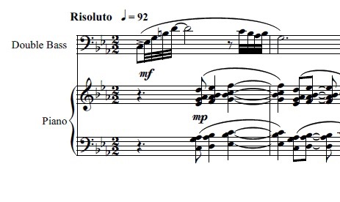
Example 4: Mars, Bars 1-3

The piece continues developing these themes by using similar rhythmic motifs beginning on different pitches, finally resolving to the tonic C in bar 19. After a short piano interlude, the double bass returns this time with a lyrical and contemplative melody with entirely new material in the melody line, but retaining a similar piano part as seen in Example 4.1.
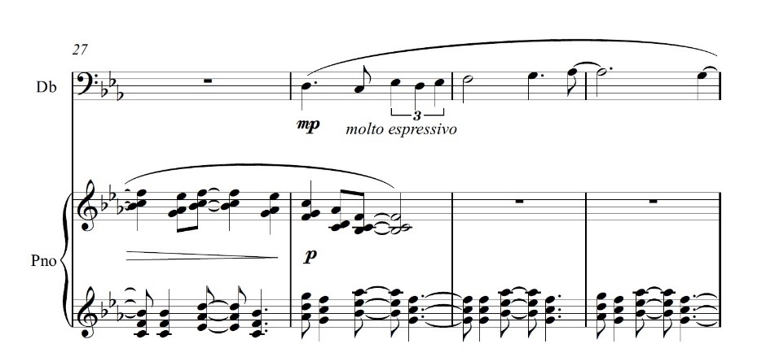
Figure 4.1: Mars, Bars 27-30

The melody builds in intensity over the piano line, as if rippling over it, as can be seen in Example 4.2.
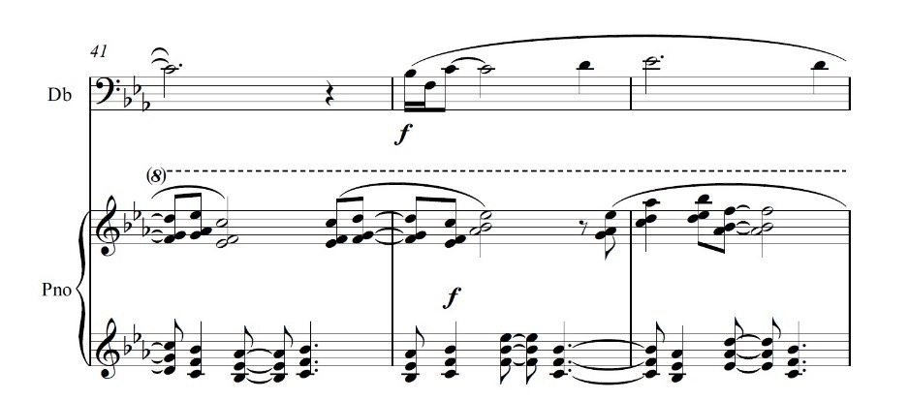
Example 4.2: Mars, Bar 41-43

Following this, the initial theme returns, this time with added volume and deeper bass piano octaves, making the sound richer and fuller than the first time. The ending is grounded, full and sincere.

Part 2 is called Red Mysteries and has a rather different character of stillness and introspection. When writing this section, I was reflecting that Mars largely remains a mystery to humans and holds many secrets. In many ways it is a meditation on not-knowing. The cornerstones of the opening melody are A – E♭, a tritone, that leans on and explores the discord created through repetition of the interval as can be seen in Example 4.3.
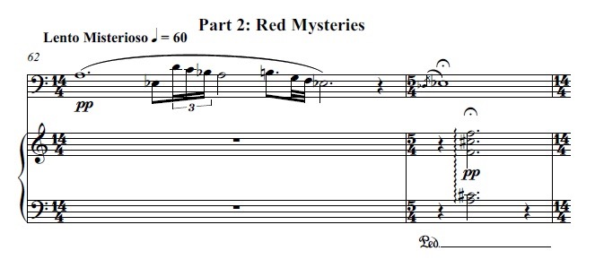
Example 4.3: Mars, Bars 62-63

Part 3, titled Red Children, insists on a playful resolution to the work and is only two minutes long. I was imagining a distant future of human colonies on Mars and the aesthetic of human beings trying to colonize a place that was not designed for them. It is marked “Agitato” with crotchet equaling 192 with a driving repetitive piano line that stays buoyantly staccato throughout. The double bass enters with a syncopated chromatic melody at bar 93 then continues in an agitated, fragmented fashion, as if a child lumbering along in a spacesuit, as shown in Example 4.4.
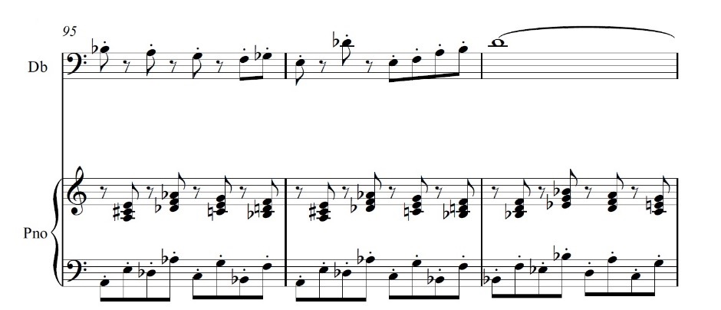
Example 4.4: Mars, Bars 95-97

The phrase ends with a distinctive triplet crotchet motif, as shown in Example 4.5.
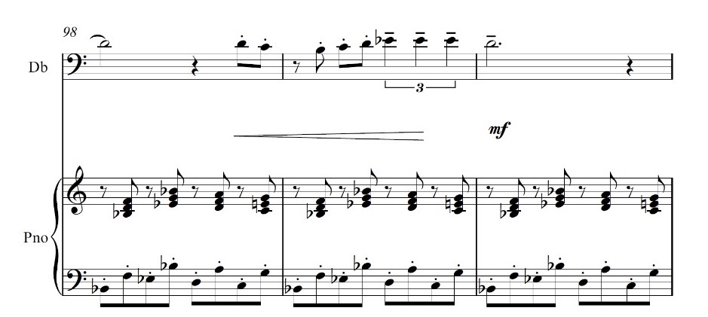
Example 4.5: Mars, Bars 98-100

This eight bar melody is developed by interchanging the lines between piano and double bass as well as changing the tonal centre. Finally, and triumphantly, the work ends with an approximate rhythmic unison rendition of the main eight bar theme between piano and double bass, ending with the distinctive triplet crotchet motif recurs on a cluster chord with D in the bass, as seen in Example 4.6.
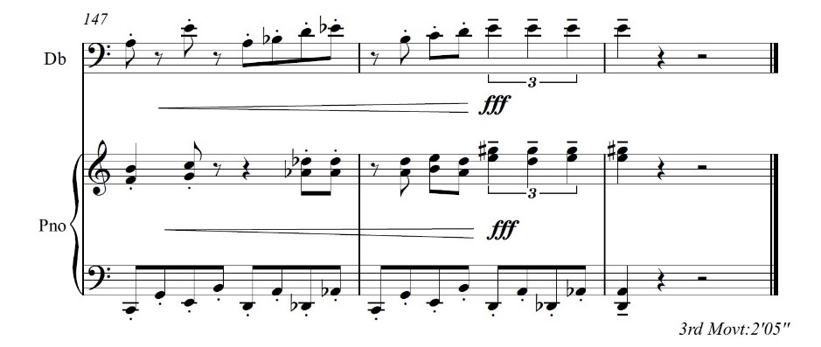
Example 4.6: Mars, Bars 147-149

- FULL MOON for solo trumpet
Full Moon was originally written for solo clarinet, but as I decided to re-devise it for solo trumpet as I was working regularly with William Gilbert, a Sydney based jazz trumpeter. With frequent consultations and his suggestion to add a large amount of reverb during performance, it worked very well.

I was inspired to write this piece after seeing some footage from NASA’s Grail mission to map the moon in 2012. The moon seemed serene, ghostly, unhuman, impartial. I have tried to capture this essence in the music. The opening melody is very slow and thoughtful, meandering, featuring slow ascending septuplets shown in Example 5, as if walking and relatively weightless on the moon itself.

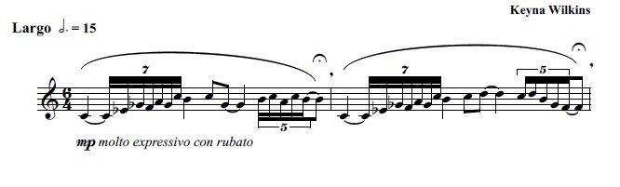
Example 5: Full Moon, Bars 1-2

The following Section B (bar 7-11) moves faster and is lighter and more optimistic using many perfect fourth intervals and using outlines of a number of extended jazz chords such as Bar 7, in Example 5.1, roughly outlining the Dm♭6♭9 chord.
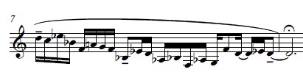
Example 5.1: Full Moon, Bar 7

Section C (Bar 13-18) uses slow sliding notes as the energy pulls back again and the flight of fancy is gone.
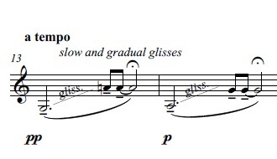
Example 5.2: Full Moon, Bar 13
Section A returns at the end, reiterating the deep stillness and void as you look beyond the horizon away from planet Earth as shown in Image 4.

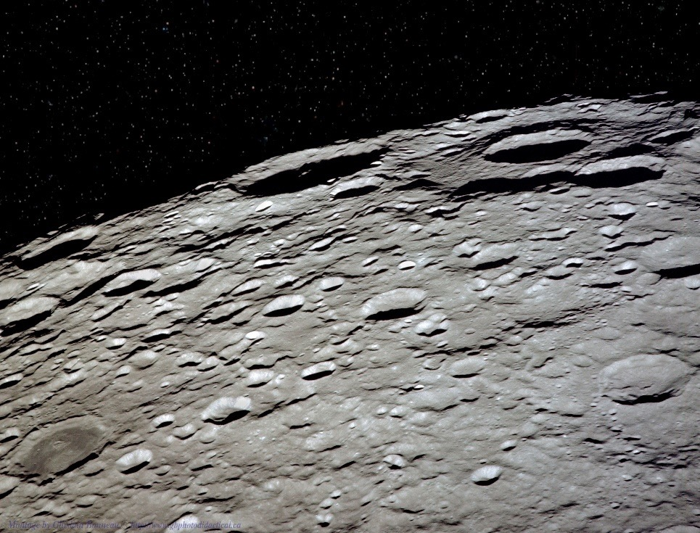
Image 4: NASA image of the moon 2012

- SKY PIECES for solo piano
Sky Pieces is a collection of eight piano miniatures one-two minutes in length, embodying different aspects of Earth’s sky such as clouds, wind and distant horizons. It was my first serious attempt at a set of pieces after being asked by Wirripang, to expand a single piano piece into a book of eight separate pieces the intermediate – advanced pianist. My inspiration for these pieces was Claude Debussy. His charismatic melodies and dream-like atmospheres in the context of modal tonalities, harmonies involving parallel sevenths/fifths/fourths and rhythmic pulse ambiguity, is something I aspired to. Sky Pieces certainly has lyrical melodies, often modal in tonality, some using ostinato, with a single theme developing in an improvisatory dream-like manner.
While it is not known how strong Debussy’s interest in astronomy was, he did write Claire de Lune, suggesting a degree of curiosity. In 2010 ‘Space Daily’ reported a crater on Mercury was named Claude Debussy along with nine other Mercurian craters which were named after prominent artists and composers.

The first, Soar, was an improvisation around Am sus4 (A minor triad with D) and B♭M7 (B♭ major triad with A) which was later notated. The left had part remains largely the same throughout, alternating between these two chords in demisemiquaver arpeggiated forms. “Soar” refers to the right hand melody soaring every higher into stratospheric piano realms over the rolling hills of the left hand part, which are indeed mountainous in shape as can be seen in Example 6.

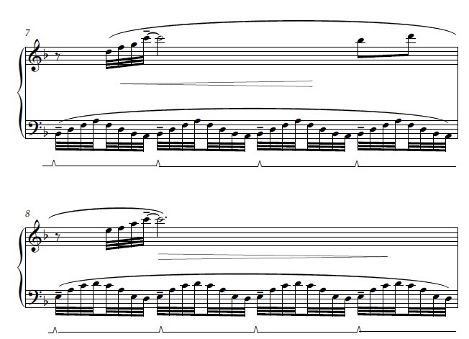
Example 6: Soar, Bars 7-8

The second, Cloud, is the most reverie-like of the collection, drifting in and out of melody fragments briefly only for them never to return, as if daydreaming while gazing at clouds and pondering their shapes. It is based on C major chord in left hand over the C# major chord in right hand – a fleeting experiment with bitonality, exploring the dissonant semitone intervals created, shown in Example 6.1. Higher octave right hand melodies float above with a highly shifting pulse with multiple time signature changes.
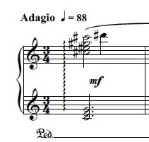
Example 6.1: Cloud, Bar 1

Distant Horizon is the third and is a slow, contemplative and meandering piece concerned with memory and acceptance which is symbolized by the slow tempo, crotchet equals 49 bpm, and frequent pauses for thought and reflection. Parallel sus4 7 chords (mostly minor sevenths and sometimes augmented fourths) form the basis of the melodic and harmonic content as shown in Example 6.2.
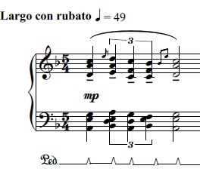
Example 6.2: Distant Horizon, Bar 1

The subversive rhythmic effect of quintuplets, sextuplets and triplets over duplets, as well as grace notes and pauses contributes to an ambiguous pulse, shown in Example 6.3.
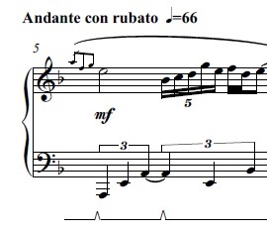
Example 6.3: Distant Horizon, Bar 5

The fourth is Wind and uses ostinato-like pattern in the left hand that chromatically weaves up and down perfect fifth intervals while the right hand melody is based on consecutive mostly tritone intervals shown in Example 6.4.
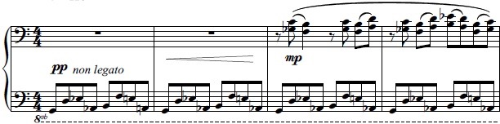
Example 6.4: Wind, Bars 1-4

The piece develops using an ostinato E Phrygian mode semiquaver pattern in the right hand and melody in the left hand using similar rhythms to the previous right hand melody. Following this, consecutive sus4 7 chords (mostly minor seventh intervals and perfect fourths) build to an optimistic ending on E sus4 7, shown in Example 6.5.
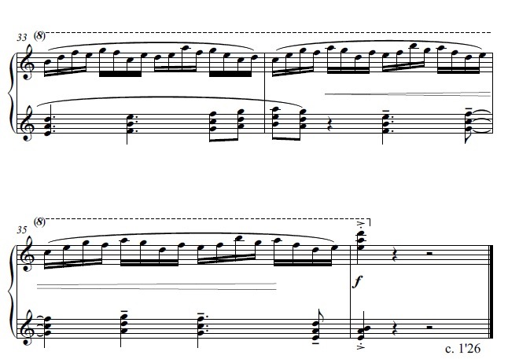
Example 6.5: Wind, Bars 33-36

Breeze is the fifth and opens with a floating melody over two chords Dm♭6 (D minor triad with the addition of a flattened sixth) and A♭+6 (A♭ augmented triad with major sixth), a rolled chord written out in demi-semi-quavers, which can be seen in Example 6.6, and evolves into left hand led melody, with similar right hand chords as the first section. What follows is an improvisatory development with a steady two chords arpeggiated in the left hand while the right hand melody soars into the next octave.

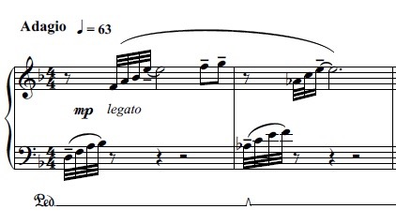
Example 6.6: Breeze, Bar 1

The sixth piece of the collection is Blue Skies and is a shamelessly optimistic piece articulating the bright blue of Earth’s atmosphere. It centres around an E Lydian (with a flattened third) shaped ostinato which is developed through inversion and staggered entries between the left and right hand, shown in Example 6.7. It briefly transitions to G tonal centre midway through, quickly returning to E. Building in excitement by ascending and accelerating towards the end, this piece reflects associations with ‘blue sky thinking’.

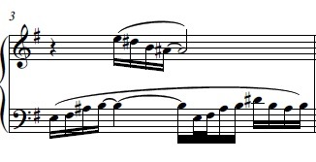
Example 6.7: Blue Skies, Bar 3

Glow in the Fog is the seventh and was written in a similar vein to Cloud using many rolled chords and avoids a steady pulse with many pauses. Slow and contemplative, it embodies the opaque nature of Earth’s atmosphere. Based around Dm-6 rolled chord in various inversions, it uses una corda to add a subtler tone colour in more delicate sections, shown in Example 6.8.
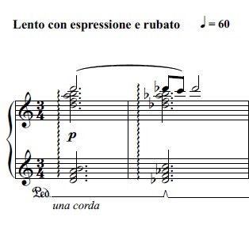
Example 6.8: Glow in the Fog, Bars 1-2

The final piece in the collection is Leaf in the Wind, a highly agitated intense piece. Throughout the whole piece there is a left hand 4 quaver ostinato pattern using the intervals of a perfect fifth and diminished fifth, seen in Example 6.9, sometimes transitioning into different tonal centres, but mostly around A.
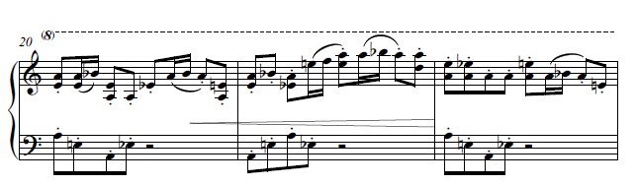
Example 6.9: Leaf in the Wind, Bars 20-23

Over this ostinato the right hand initially has fragmented melodies, which increases in activity. Following this is the climax of the piece, a series of parallel seventh chords played fortissimo, shown in Example 6.91.
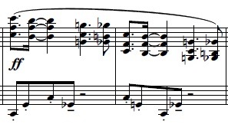
Example 6.91: Leaf in the Wind, Bar 27

Davis, H., 1901. The Republic The Statesman of Plato. London: M. W. Dunne (p252)
http://edition.cnn.com/2016/02/21/world/far-side-moon-music/
http://australiancomposers.com.au
Keister, J., 2004. The Shakuhachi as a Spiritual Tool: A Japanese Spiritual Instrument in the West. Asian Music Spring/Summer 2004 Volume XXXV Number 2
Heather, S., 2005. The Healing Power of Intervals London: self-published
Spacedaily Online available at: http://www.spacedaily.com/reports/Ten_Craters_On_Mercury_Receive_New_Names_999.html (accessed 5/8/2016)

